Title

Author name^{1*}, Author², Author³
^{1,2,3} Civil Engineering Department, Jaypee University of Information Technology, Waknaghat, Solan, Himachal Pradesh 173234, India.

*Corresponding Author :abc1@gmail.com

Abstract
Municipal solid wastes (MSW) are mostly decomposable solid waste, which under aerobic and anaerobic decomposition produces Green house gases and almost 50% of the green house gases consists of Methane gas. The landfills used for waste disposal acts as a source of methane (CH₄) gas. As methane has higher green house potential as compared to carbon dioxide (CO₂), it can significantly damage the environment as it becomes an
Keywords: Methane generation; Municipal solid waste management (MSWM); Landfill; Default Method; Modified Triangular Method; Global Warming

Introduction:
With the increase in MSW generation over years, India is facing various environmental challenges. These MSW landfills results in the increase of microbial pathogens which are polluting air as well as water [1]. Organic components of MSW plays a major role in the emission of green house gases, which leads to global warming and is a responsible for climate change and is ultimately treat to all livings creature in this planet [3, 4, 8, 9, 10, 12].
Generation of waste in Mohali city:
Table 1. Calculation of waste (in Kg/day) per capita generation
S. No. | Year | Waste per capita (Kg/day) | Comments/Remarks
1 | 2015 | 0.458 | Population basis
Individual disposal of waste in 2015 and 2016 is considered to be the allocation for a specific population and for 2017; waste per capita is estimated based on the overall amount of MSW in Mohali on daily basis and as per the 2011 Govt. of India Census report [2, 9].
An average waste of 0.481 kg/day is used in conjunction with the population growth expected to compute the amount of per capita waste generated in the various years into consideration. The population of the city taken in this has been calculated using a geometric growth method [2]. Total city waste disposal per annum and the
Methane generation associated with the default method is based on the following equation: [5]
${CH}_{4}\left(\frac{Gg}{year}\right)=({MSW}_{T}×{MSW}_{F}×MCF×DOC×{DOC}_{F}×F×\frac{16}{12}-R)×(1-OX)$ (1)
(ii). Modified Triangular method (MTM) of methane generation:
then zero to 16 years. The Triangular form of methane generation is illustrated in figure 1 below:
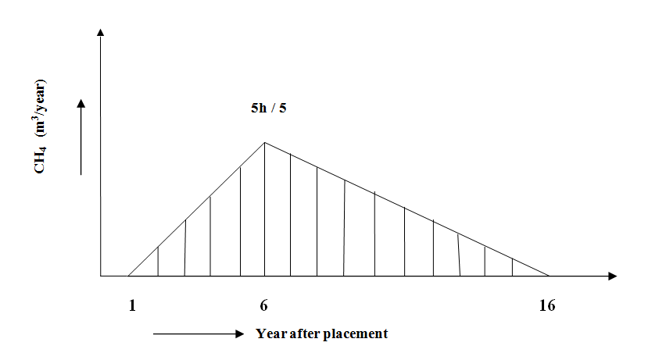
Figure1. Triangular shape of gas generation
Results and Discussion:
(a). Methane generation by IPCC’s Default Method:
Conclusions:
- An estimate of 810 Gg of MSW reaching landfills/dumpsites in Mohali city in next 16 years which poses a threat to environment be it soil pollution, groundwater pollution or air pollution. Apart from different types of pollution caused by landfills, anaerobic decomposition of waste produces methane gas

References:
[1] Bhuvanendran, Reji & Shimi, S.L. (2010). Municipal Solid Waste Management: Projection of Methane Emission from Landfill Disposal System in Chandigarh.
[2] Gawatre, D., Kandgule, M. and Kharat, S., 2016. Comparative Study of Population Forecasting Methods. IOSR Journal of Mechanical and Civil Engineering, 13(04), pp.16-19

